B.M.S COLLEGE OF ENGINEERING BENGALURU
Autonomous Institute, Affiliated to VTU



SPC AAT Report on

BANK ACCOUNT SIMULATOR

Submitted in partial fulfillment of the requirements for AAT

Bachelor of Engineering
in
Computer Science and Engineering

Submitted by:

NAME OF THE CANDIDATE

AMIT HIPPARAGI

Department of Computer Science and Engineering
B.M.S College of Engineering
Bull Temple Road, Basavanagudi, Bangalore 560 019
2025-2026

B.M.S COLLEGE OF ENGINEERING
DEPARTMENT OF COMPUTER SCIENCE AND ENGINEERING



DECLARATION

We, PH students of 1st Semester, B.E, Department of AIML BMS College of Engineering, Bangalore, hereby declare that, this AAT Project entitled "BANK ACCOUNT SIMULATOR" has been carried out in Department of CSE, BMS College of Engineering, Bangalore during the academic semester Oct 2024 – Jan 2025. We also declare that to the best of our knowledge and belief, the AAT Project report is not from part of any other report by any other students.

Student Name Student Signature
1.Aditya
2. Amit Hipparagi

BMS COLLEGE OF ENGINEERING
DEPARTMENT OF COMPUTER SCIENCE AND ENGINEERING

CERTIFICATE

This is to certify that the AAT Project titled “bank Account Simulator “has been carried out by Amit Hipparagi during the academic year 2025-2026.

Signature of the Faculty in Charge

Table of Contents
Sl. No. | Title | Page no.
1 | Introduction | 1
2 | Algorithm | 2
3 | Flowchart | 3
4 | Source code | 4-7
5 | Results (screenshots) | 8
6 | References | 9

1. INTRODUCTION
Banking systems are an essential part of modern society, handling financial transactions securely and efficiently. With the growth of digital banking, software-based banking applications have become increasingly important. Understanding the basic working of such systems helps engineering students gain practical knowledge of programming concepts.

This project titled “Bank Account Simulator Using C Programming” is designed to simulate basic banking operations such as account creation, deposit, withdrawal, balance inquiry, and transaction history. The program is implemented using the C programming language and demonstrates core programming concepts including structures, functions, arrays, conditional statements, loops, and string handling.

The project also includes a password-based authentication mechanism to ensure secure access during withdrawal operations. This simulator is suitable for academic learning and provides a foundation for understanding real-world banking software systems.
Problem statement
In today’s digital era, banking operations such as depositing money, withdrawing funds, checking account balance, and maintaining transaction records are commonly handled through computerized systems. For students learning programming in C, understanding how such real-world systems can be modeled using basic programming constructs is essential.
The problem is to design and implement a Bank Account Simulator using the C programming language that allows a user to securely manage a bank account. The system should support basic banking operations, maintain account details, ensure password-based authentication, and record transaction history in a simple, menu-driven environment.
Objectives

The main objectives of the Bank Account Simulator project are:
- To design a menu-driven C program that simulates basic banking operations.

2. To implement account creation with user details such as name, account number, and password.

3. To provide functionality for depositing and withdrawing money with proper validation
2.ALGORITHM
Step 1: Start the program
Step 2: Declare a structure to store account details (name, account number, balance, password)
Step 3: Initialize global variables for transactions and transaction count
Step 4: Accept user input to create a bank account
Read account holder name
Read account number
Set account password
Initialize balance to zero
Step 5: Display the main menu repeatedly
1. Deposit money
2. Withdraw money
3. Check balance
4. View account details
5. View transaction history
6. Exit
Step 6: Perform operation based on user choice
Deposit:
Check for valid amount
Update balance
Store transaction
Withdraw:
Authenticate password
Check balance
Deduct amount
Store transtion
Check Balance: Display current balance
Account Details: Display user details
Transaction History: Display all deposits and withdrawals
Step 7: If exit option is selected, terminate the program
Step 8: Stop
3. FLOWCHART

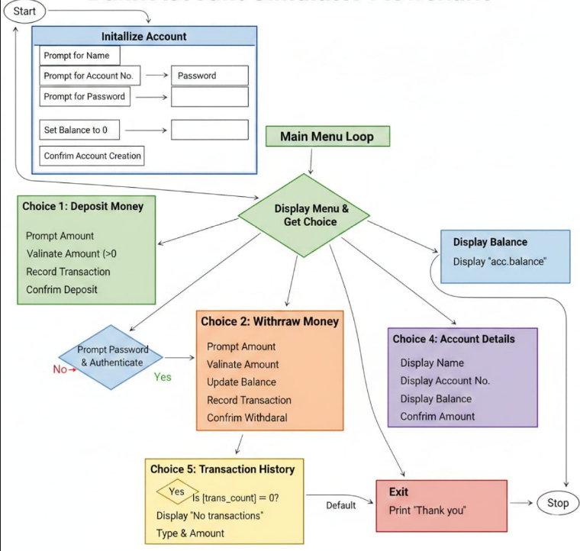

4.Source code
#include <stdio.h>
#include <string.h>

/* Structure to store bank account details */
struct BankAccount {
char name[30];
int acc_no;
float balance;
char password[10]; // Password is now part of the account
};
/* Global variables */
struct BankAccount acc;
float transactions[MAX_TRANS];
int trans_count = 0;
/* Function to check password against the account password */
int authenticate() {
char input_pass[10];
printf("Enter Password: ");
scanf("%s", input_pass);
if (strcmp(input_pass, acc.password) == 0) {
return 1;
} else {
printf("Access Denied: Incorrect Password!\n");
return 0;
}
}
/*Function to deposit money */
void deposit(float amount) {
if (amount > 0) {
if (trans_count < MAX_TRANS) {
acc.balance += amount;
transactions[trans_count++] = amount;
printf("Amount Deposited: %.2f\n", amount);
} else {
printf("Transaction limit reached!\n");
}
} else {
printf("Invalid deposit amount!\n");
}
}
/* Function to withdraw money with security check */
void withdraw(float amount) {
// Check password BEFORE checking balance or processing
if (!authenticate()) {
return; // Exit function if password is wrong
}

if (amount > 0 && amount <= acc.balance) {
if (trans_count < MAX_TRANS) {
acc.balance -= amount;
transactions[trans_count++] = -amount;
printf("Withdrawal Successful! Amount: %.2f\n", amount);
} else {
printf("Transaction limit reached!\n");
}
} else {
printf("Insufficient balance or invalid amount!\n");
}
}
/* Function to display balance */
void check_balance() {
printf("Current Balance: %.2f\n", acc.balance);
}
/* Function to display account details */
void account_details() {
printf("\n--- Account Details ---\n");
printf("Name : %s\n", acc.name);
printf("Account No : %d\n", acc.acc_no);
printf("Balance : %.2f\n", acc.balance);
}
/*Function to show transaction history */
void transaction_history() {
int i;
if (trans_count == 0) {
printf("\nNo transactions yet.\n");
return;
}
printf("\n--- Transaction History ---\n");
for (i = 0; i < trans_count; i++) {
if (transactions[i] > 0)
printf("Deposit : %.2f\n", transactions[i]);
else
printf("Withdraw : %.2f\n", -transactions[i]);
}
}
int main() {
int choice;
float amount;
/* Initialize account */
printf("--- Create Your Account ---\n");
printf("Enter Account Holder Name: ");
// Clear buffer and use fgets for names with spaces
// scanf(" %[^\n]s", acc.name);
fgets(acc.name,100,stdin);
printf("Enter Account Number: ");
scanf("%d", &acc.acc_no);
printf("Set your Account Password: ");
scanf("%s", acc.password);
acc.balance = 0.0;
printf("\nAccount created successfully!\n");
while (1) {
printf("\n===== BANK ACCOUNT SIMULATOR =====\n");
printf("1. Deposit Money\n");
printf("2. Withdraw Money\n");
printf("3. Check Balance\n");
printf("4. Account Details\n");
printf("5. Transaction History\n");
printf("6. Exit\n");
printf("Enter your choice: ");
scanf("%d", &choice);
switch (choice) {
case 1:
printf("Enter deposit amount: ");
scanf("%f", &amount);
deposit(amount);
break;
case 2:
printf("Enter withdrawal amount: ");
scanf("%f", &amount);
withdraw(amount);
break
case 3:
check_balance();
break;
case 4:
account_details();
break;
case 5:
transaction_history();
break;
case 6:
printf("Thank you for using the Bank Simulator!\n");
return 0;
default:
printf("Invalid choice! Try again.\n");
}
}
return 0;}

5 RESULTS

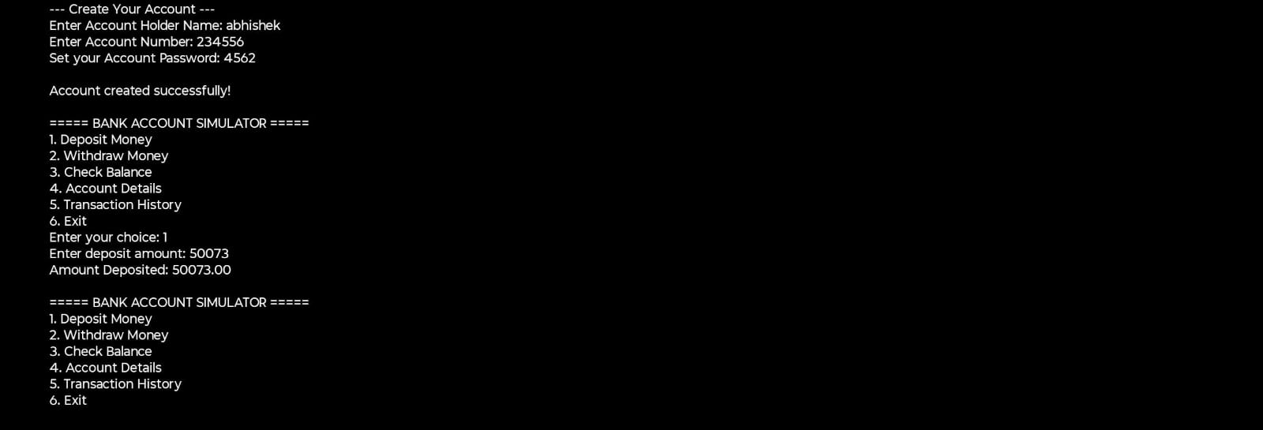
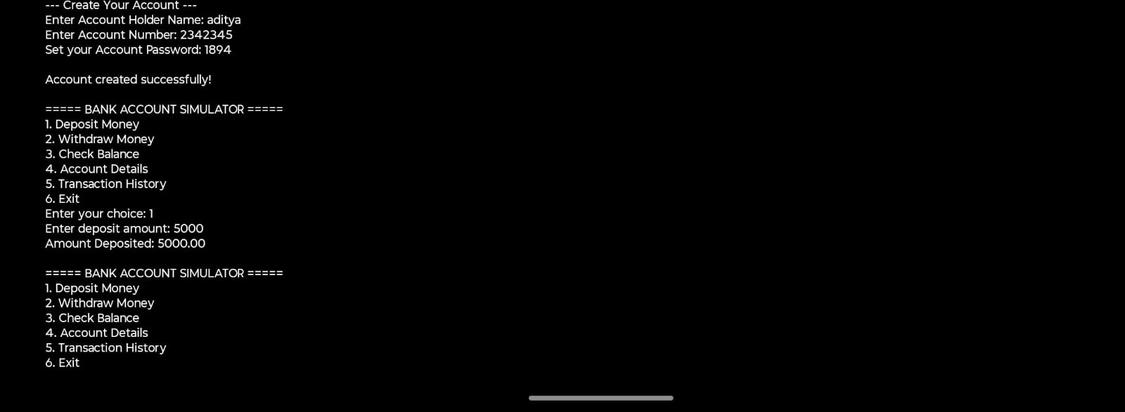

REFERENCES

1. Dennis M. Ritchie, The C Programming Language, 2nd Edition,
Prentice Hall, 1988.
2. E. Balagurusamy, Programming in ANSI C,
McGraw Hill Education, India.
3. Brian W. Kernighan and Dennis M. Ritchie,
C Programming Language, Pearson Education
B.M.S. College of Engineering, Dept. of CSE. AAT Project Guidelines and Report
Format 2024-2025.

